**General Questions & Answers:**

**Q1: Can QGroundControl interact with the autopilot while in flight?**

Yes Q-GroundControl can communicate with Pixhawk4 while in flight. Additional telemetry is required and has been added to the Quadcopter BOM.

**Q2: How can SLA software integrate into the [https://docs.px4.io/en/config/safety.html]“Safety Configuration (Failsafe)” modes available in PX4?**

PX4 has the following failsafe flight modes:

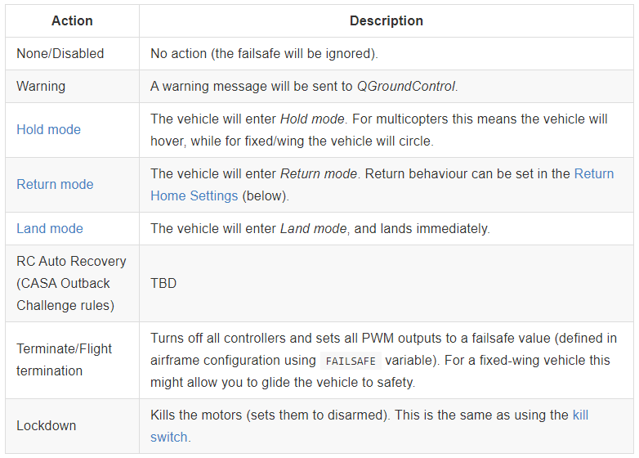

PX4 can transition between flight modes using switches on the remote or ground control station. These flight modes are activated based on the PWM value of a channel. The channel and the flightmode/PWM assignments are configured in Q-GroundControl. Using Single Channel Mode Selection up to 6 flight modes can be encoded on a single channel. Using Multi Channel Mode Selection you can assign modes to switch positions encoded in one or more channels. Single Channel Mode Selection is easier to configure and understand. The SLA software could communicate these PWM signals to the specified port to trigger the failsafe flight modes. These should also be programmed to switches on the remote control. [PX4 flight mode configuration](https://docs.px4.io/en/config/flight_mode.html)

**Q3a: Are there any command and control methods that could be bound to the “AUX Passthrough Channels” of a transmitter? Stablize ON/Off? Track enable? Landing Enable?**

AUX passthrough channels allow you to control arbitrary optional hardware from your transmitter (for example, a gripper).

To use the AUX passthrough channels:

1. Map up to 2 transmitter controls to separate channels.
2. Specify these channels to map to the AUX1 and AUX2 ports respectively, as shown below. Values are saved to the vehicle as soon as they are set.

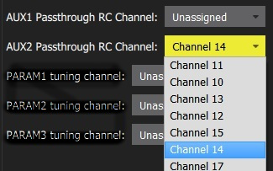

**Q3b: If so, how does the receive/autopilot communicate that to the 1500-OEM?**

The flight controller will pass through the unmodified values from the specified channels out of AUX1/AUX2 to the connected servos/relays that drive your hardware.

You can assign command and control parameters to the aux outputs that are connected to the transmitter or Ground Control Station in Q-GroundControl outlined [here.](https://docs.qgroundcontrol.com/en/SetupView/Radio.html#param-tuning-channels-px4)

**Q4: How are the “Camera Controls” transmitted to a camera? Are there**

**Q5: What is the [https://docs.px4.io/en/advanced_config/land_detector.html]“Land Detector Configuration”?**

**Q6: What else is needed for [https://docs.px4.io/en/advanced_features/precland.html]“Precision Landing”?**

**Q7: Is it valuable to compare our landing aid to the IR-Lock MarkOne?**

**Sensor: [https://irlock.com/products/ir-lock-sensor-precision-landing-kit?variant=2022285059]IR-LOCK Sensor ($99) + Cable ($6)**

**Beacon: [https://irlock.com/collections/markone/products/markone-beacon-v2-0?variant=45031002691]MarkOne Beacon V2.0 ($139) - Additional cables and power supplies not listed**

**Q7b: Is there value in creating a plug in replacement for the IR-Lock Sensor?**

**Q8: Is it valuable to compare to a range finder?**

**Sensor: [https://irlock.com/collections/rangefinders/products/sf30-c-100-m?variant=15891310346291]SF30/C ($399)**

**Q9: Calibrating the 1500-OEM with the Pixhawk should involve some alignment of X&Y axis. How is this done?**

**\*\*\*\*\*\*\*\*\*\*\*\*\*\*\*\*\*\*\*\*\*\*\*\*\*\*\*\*\*\*\*\*\*\*\*\*\*\*\*\*\*\*\*\*\*\*\*\*\*\*\*\*\*\*\*\*\*\*\*\***

**Here is some additional question that we should consider.**

**Telecom1: is it also provide power to OEM?** It’s better to provide both power and serial, so we just need to use Tele1 to provide both power and serial for 1500 OEM which will reduce the complexity and the weight of the design.

How to fly indoor safely?